Project 6
- Day one

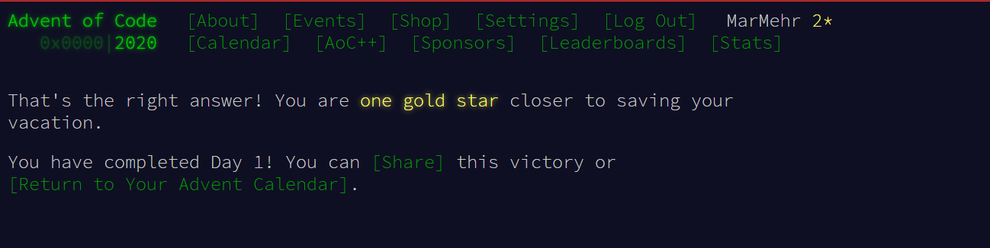
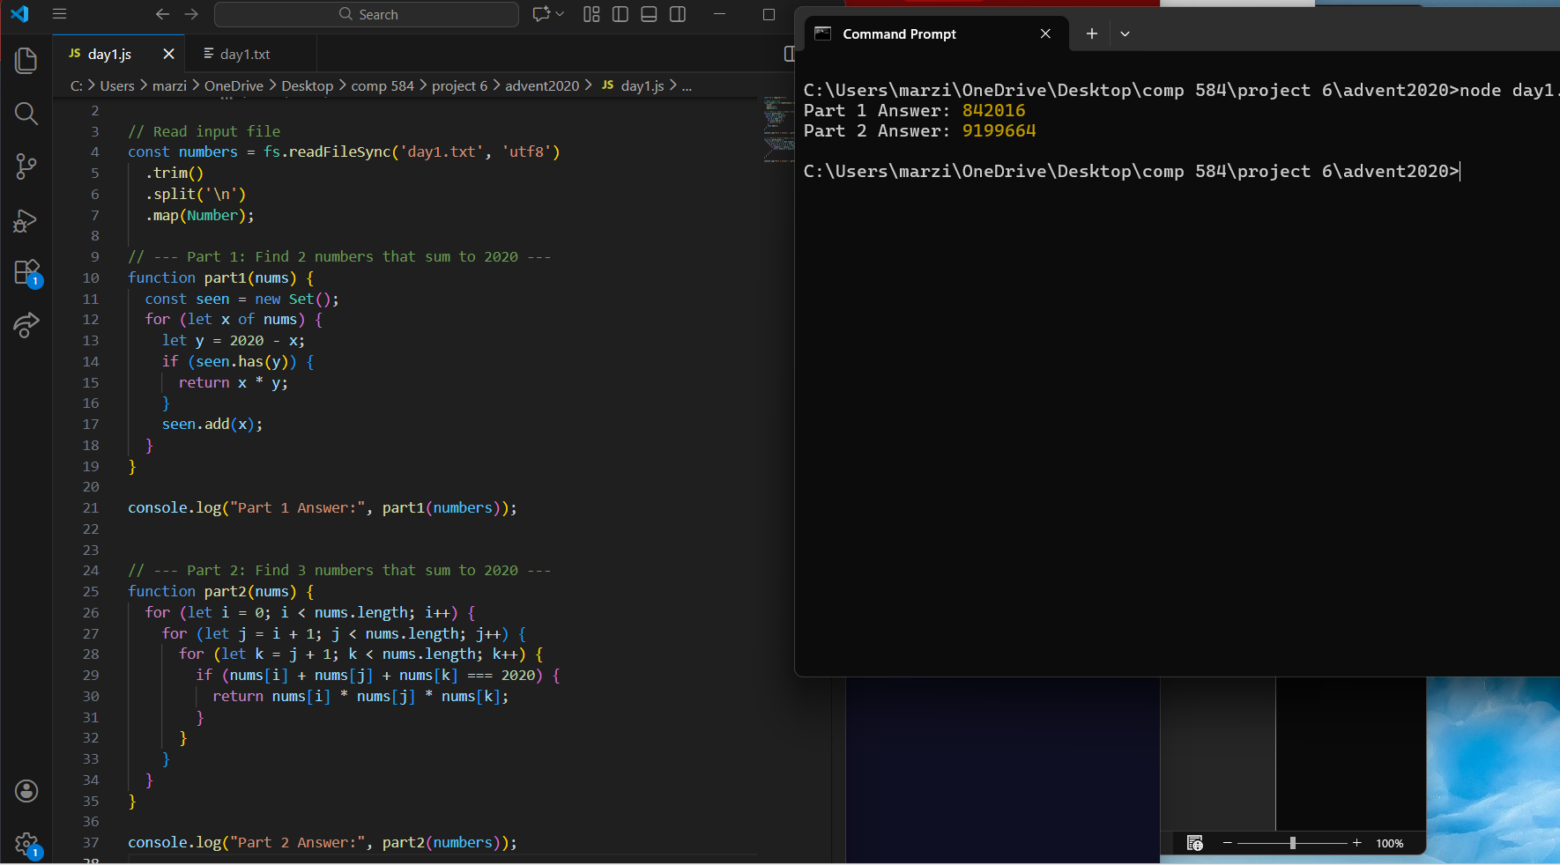

- Day2:
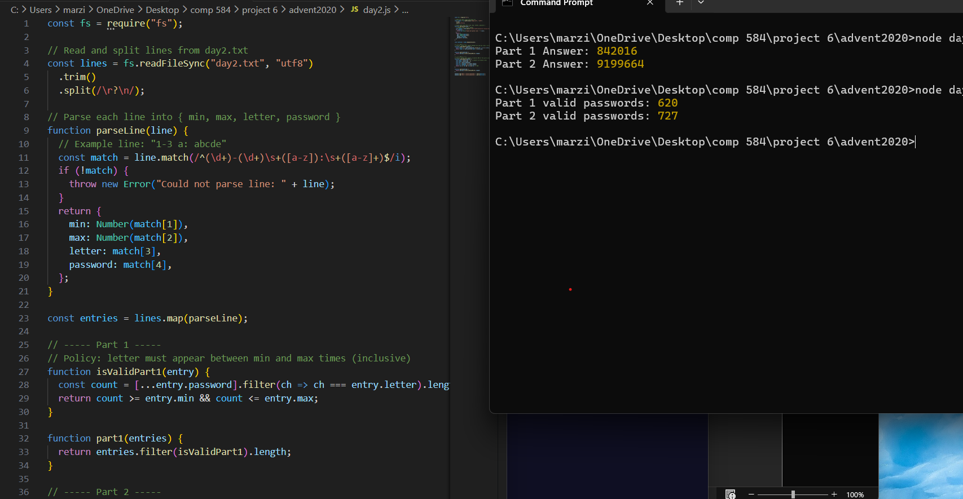

- Day3
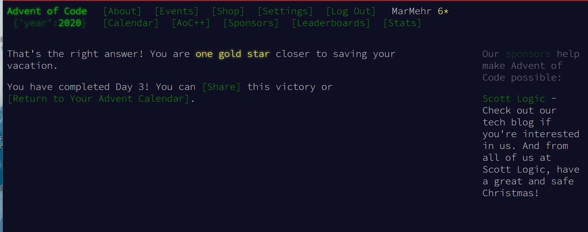
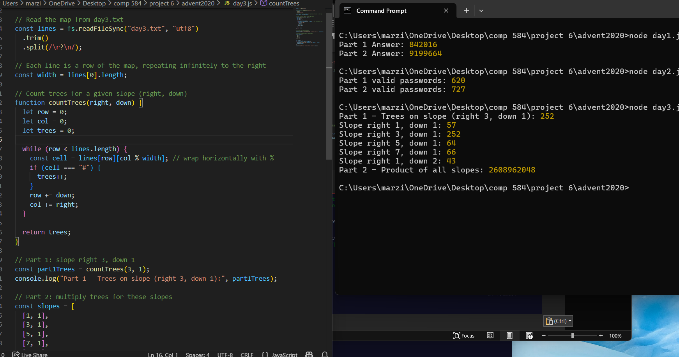

- Day4
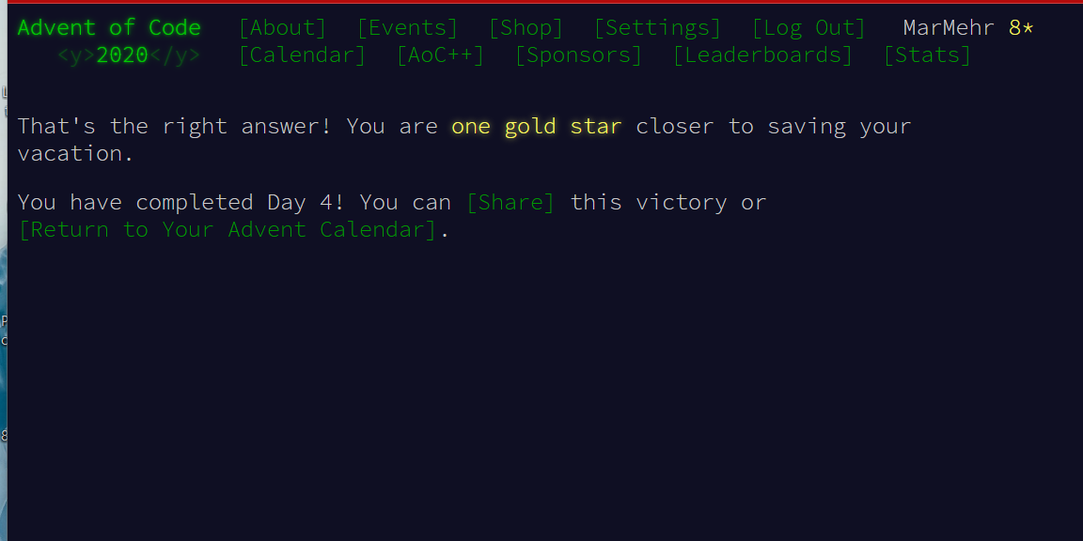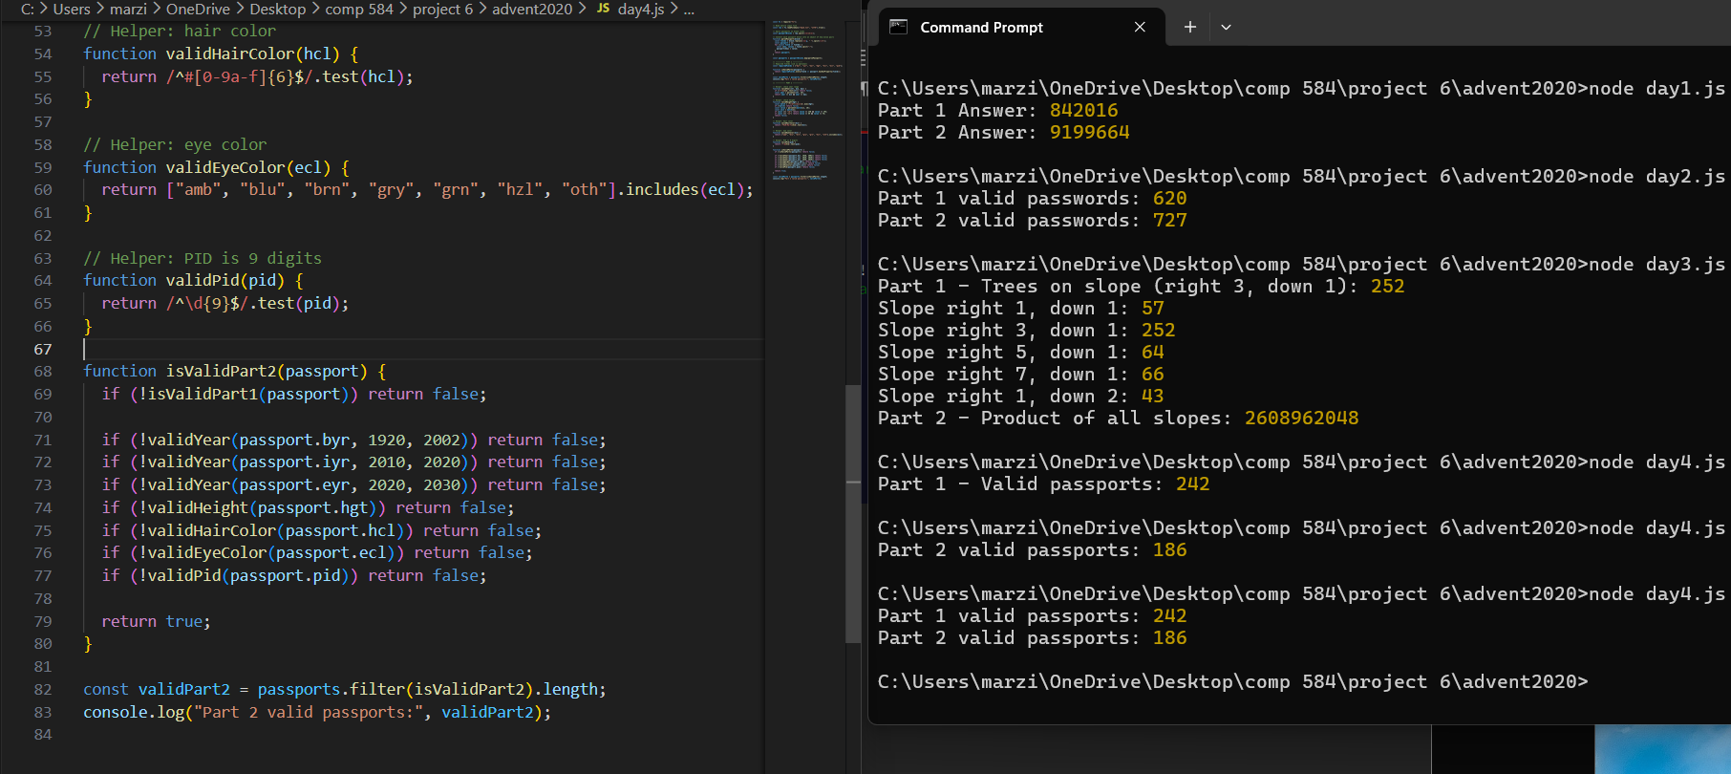
- Day5
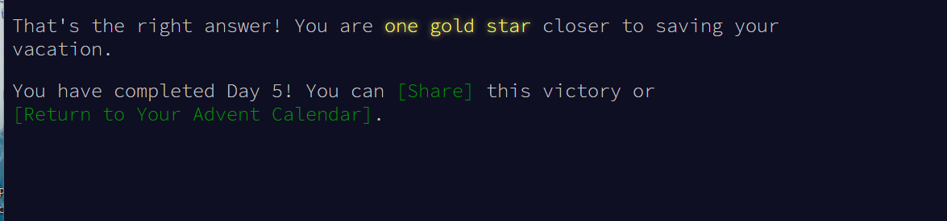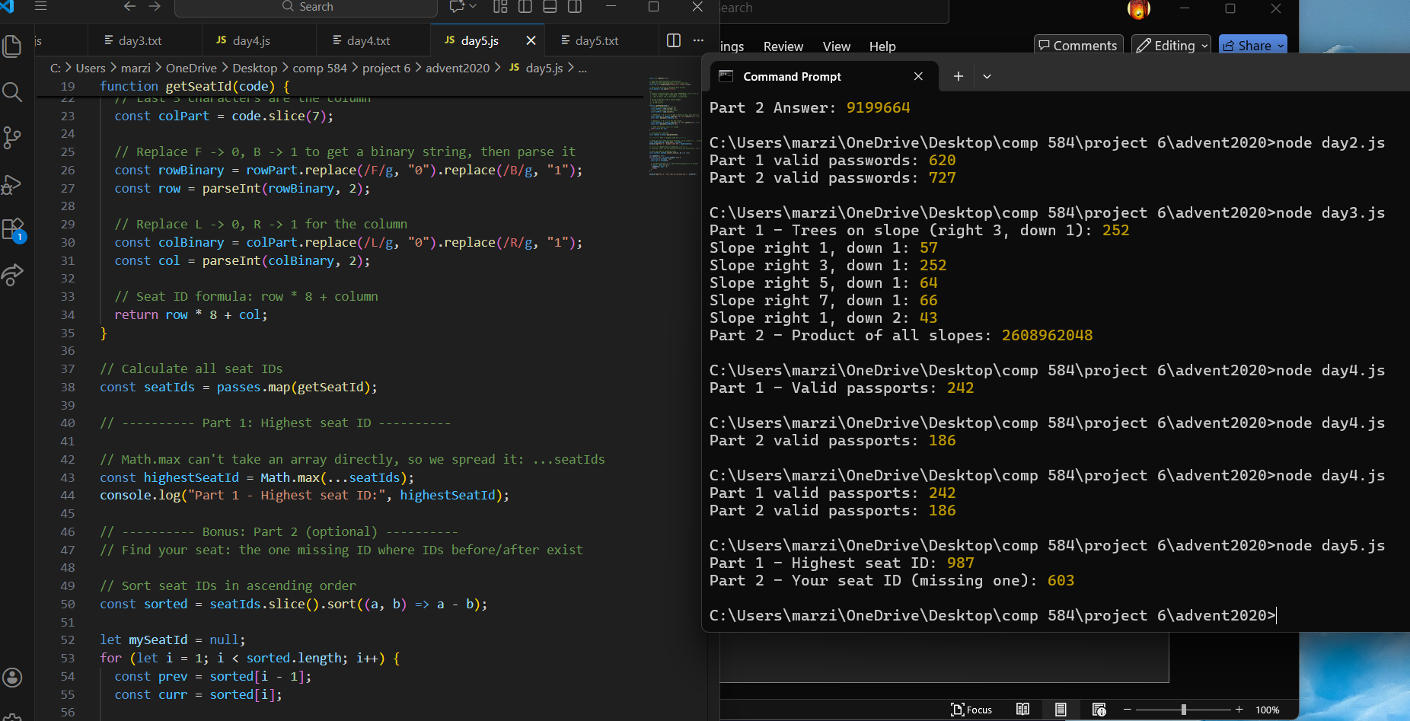
- Day6
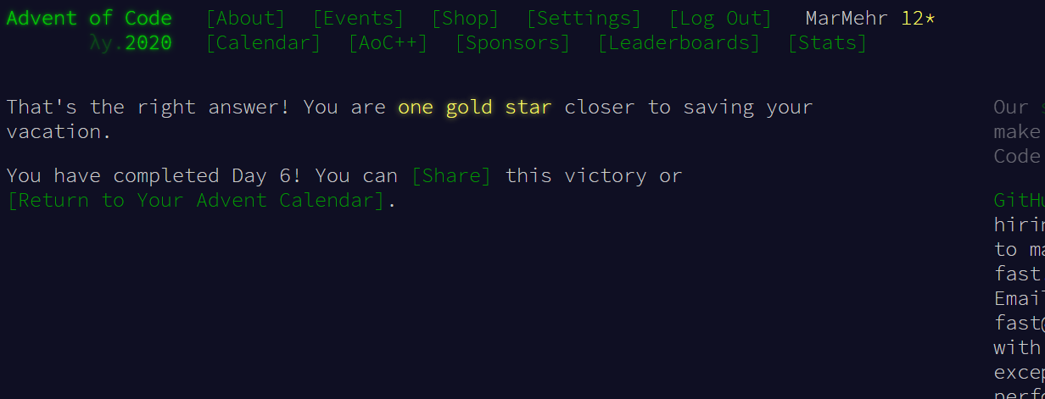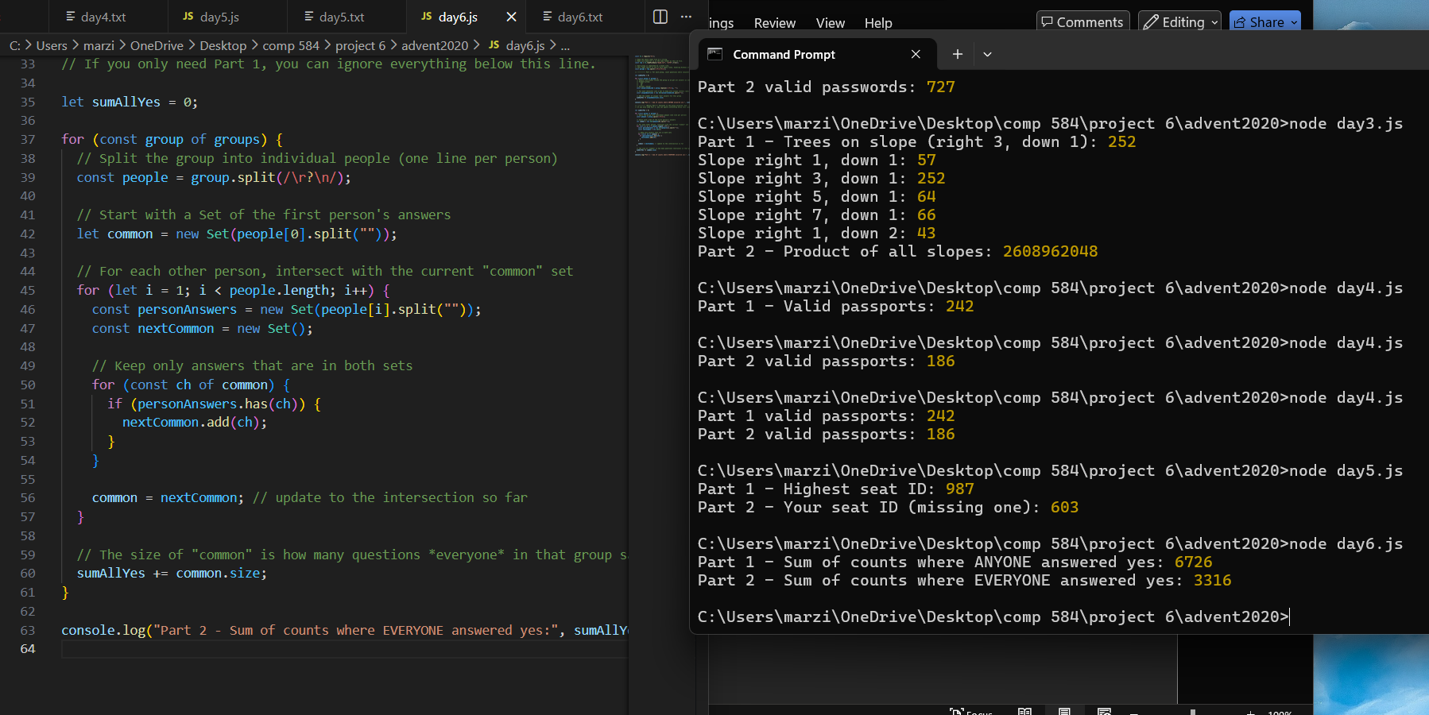
- Day7
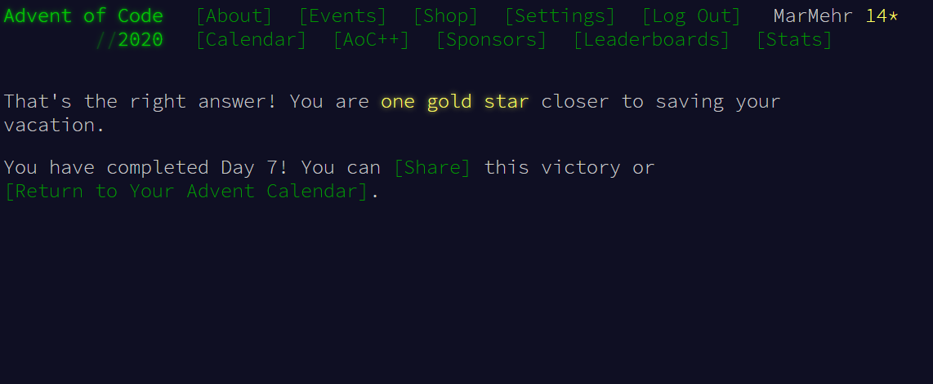
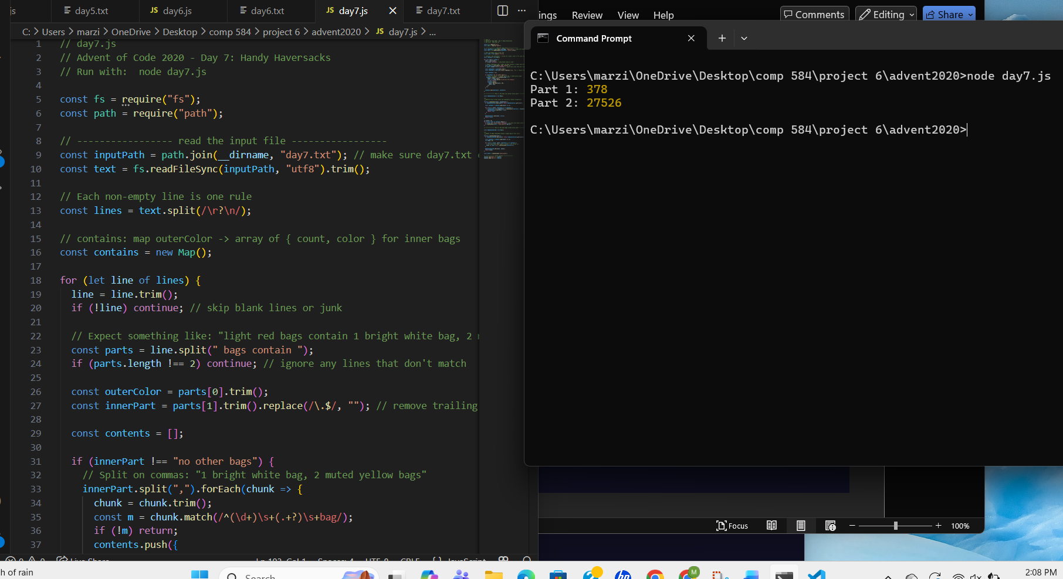

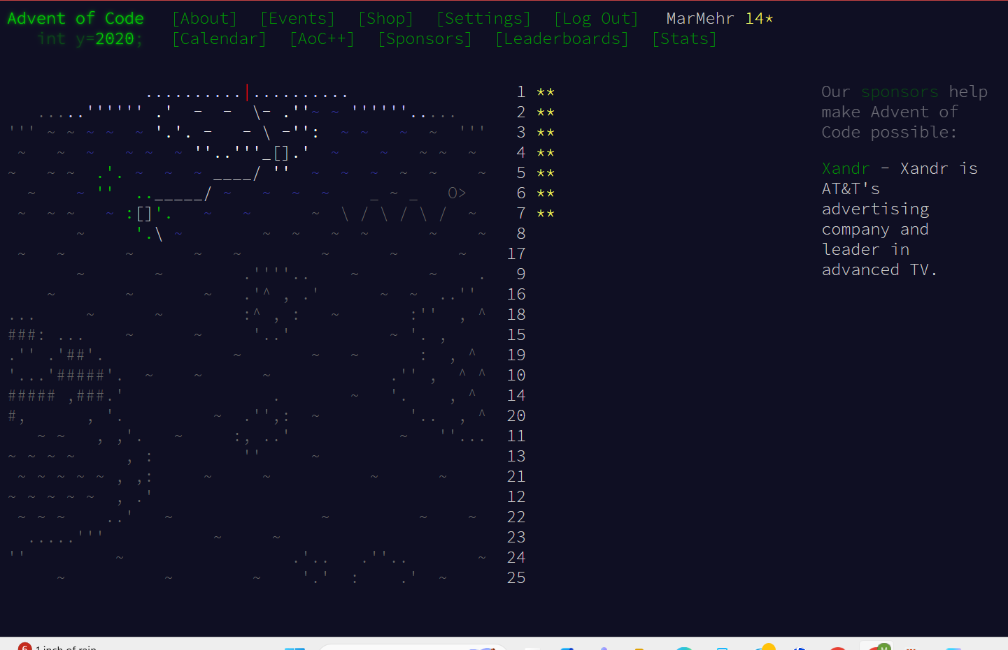

Documentation for mdn and node.js
Day 1 – Report Repair
Day 1 reads the input numbers using Node.js fs.readFileSync from the File System module
(https://nodejs.org/api/fs.html).
The file contents are split into lines using String.split
(https://developer.mozilla.org/en-US/docs/Web/JavaScript/Reference/Global_Objects/String/split), then converted to numbers using Number
(https://developer.mozilla.org/en-US/docs/Web/JavaScript/Reference/Global_Objects/Number).
A Set is commonly used to check complements efficiently for the 2-sum solution (find two numbers that add to 2020)
(https://developer.mozilla.org/en-US/docs/Web/JavaScript/Reference/Global_Objects/Set).
For the 3-number version, looping plus complement-checking is used, and the final answer is computed using multiplication (*)
(https://developer.mozilla.org/en-US/docs/Web/JavaScript/Reference/Operators/Multiplication).

Day 2 – Password Philosophy
Day 2 reads the password policy lines using fs.readFileSync
(https://nodejs.org/api/fs.html) and splits into rows with String.split
(https://developer.mozilla.org/en-US/docs/Web/JavaScript/Reference/Global_Objects/String/split).
Each row is parsed using a regular expression to extract the min/max (or positions), the target character, and the password
(https://developer.mozilla.org/en-US/docs/Web/JavaScript/Guide/Regular_Expressions).
Character counting is done using String.match (or iteration), and Array.length to count matches
(https://developer.mozilla.org/en-US/docs/Web/JavaScript/Reference/Global_Objects/String/match)
(https://developer.mozilla.org/en-US/docs/Web/JavaScript/Reference/Global_Objects/Array/length).
For Part 2’s “exactly one position matches” rule, boolean logic and the XOR-style check (!==) is used
(https://developer.mozilla.org/en-US/docs/Web/JavaScript/Reference/Operators/Strict_inequality).

Day 3 – Toboggan Trajectory
Day 3 reads the map grid using fs.readFileSync
(https://nodejs.org/api/fs.html) and splits into rows with String.split
(https://developer.mozilla.org/en-US/docs/Web/JavaScript/Reference/Global_Objects/String/split).
Movement across the repeating pattern uses modulo (%) to wrap horizontally when the x-index goes past the row length
(https://developer.mozilla.org/en-US/docs/Web/JavaScript/Reference/Operators/Remainder).
Trees are detected by indexing into each row with bracket notation (e.g., row[x])
(https://developer.mozilla.org/en-US/docs/Web/JavaScript/Reference/Global_Objects/String).
For Part 2, multiple slopes are evaluated and combined using multiplication, often with Array.reduce to multiply results together
(https://developer.mozilla.org/en-US/docs/Web/JavaScript/Reference/Global_Objects/Array/reduce).

Day 4 – Passport Processing
For Day 4, Node.js was used to read the passport data from a text file using the fs.readFileSync method from the Node.js File System module
(https://nodejs.org/api/fs.html).
The input was split into individual passports using the JavaScript String.split method, separating entries by blank lines
(https://developer.mozilla.org/en-US/docs/Web/JavaScript/Reference/Global_Objects/String/split).
Each passport was converted into an object using Object.fromEntries, allowing easy access to fields such as byr, iyr, and hgt
(https://developer.mozilla.org/en-US/docs/Web/JavaScript/Reference/Global_Objects/Object/fromEntries).
Array methods such as Array.every, Array.filter, and Array.map were used to check required fields and validate data values
(https://developer.mozilla.org/en-US/docs/Web/JavaScript/Reference/Global_Objects/Array).
Regular expressions were used to validate formatted fields like hair color and passport ID
(https://developer.mozilla.org/en-US/docs/Web/JavaScript/Guide/Regular_Expressions).

Day 5 – Binary Boarding
For Day 5, Node.js read the boarding pass input using fs.readFileSync
(https://nodejs.org/api/fs.html).
Each boarding pass was converted into a binary representation by replacing characters using String.replace
(https://developer.mozilla.org/en-US/docs/Web/JavaScript/Reference/Global_Objects/String/replace).
The binary string was converted into a number using parseInt with base 2
(https://developer.mozilla.org/en-US/docs/Web/JavaScript/Reference/Global_Objects/parseInt).
The highest seat ID was found using Math.max, and the missing seat ID was identified after sorting the array with Array.sort
(https://developer.mozilla.org/en-US/docs/Web/JavaScript/Reference/Global_Objects/Array/sort).

Day 6 – Custom Customs
Day 6 used Node.js file input via fs.readFileSync
(https://nodejs.org/api/fs.html).
Groups were separated using String.split on blank lines, and unique answers were tracked using the JavaScript Set object
(https://developer.mozilla.org/en-US/docs/Web/JavaScript/Reference/Global_Objects/Set).
For Part 1, Set.size was used to count distinct “yes” answers in each group.
For Part 2, set intersection logic was applied using array spreading and Array.filter to determine questions answered “yes” by everyone
(https://developer.mozilla.org/en-US/docs/Web/JavaScript/Reference/Global_Objects/Array/filter).

Day 7 – Handy Haversacks
Day 7 involved parsing bag containment rules using Node.js file input with fs.readFileSync
(https://nodejs.org/api/fs.html).
Bag relationships were stored using JavaScript Map objects for efficient lookup
(https://developer.mozilla.org/en-US/docs/Web/JavaScript/Reference/Global_Objects/Map).
Recursive functions were used to determine which bag colors could eventually contain a “shiny gold” bag, with memoization implemented using Map to improve performance.
Depth-first traversal logic was used to count how many bags were required inside a single shiny gold bag, applying recursion and Array.reduce
(https://developer.mozilla.org/en-US/docs/Web/JavaScript/Reference/Global_Objects/Array/reduce).
Regular expressions were used to extract bag counts and colors from each rule
(https://developer.mozilla.org/en-US/docs/Web/JavaScript/Guide/Regular_Expressions).

